PIZZA SALES SQL QUERRIES
KPI’S
- Total Revenue:
select SUM(total_price) as Total_Revenue from pizza_sales
Output:
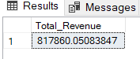
- Average Order Value:
SELECT SUM(total_price)/ COUNT(DISTINCT order_id) AS Average_Order_Value FROM pizza_sales
Output:
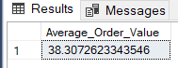
- Total Pizza’s Sold:
SELECT SUM(quantity) AS Total_Pizza_Sold FROM pizza_sales
Output:
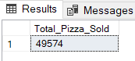
- Total Order:
SELECT COUNT(DISTINCT(order_id)) AS Total_orders FROM pizza_sales
Output:
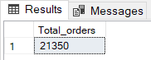

- Average Pizza Order:
SELECT CAST(CAST (SUM(quantity) AS decimal(10,2))/ CAST (COUNT(DISTINCT order_id)AS decimal(10,2))AS decimal(10,2)) AS Average_Pizza_Ordered FROM pizza_sales
Output:
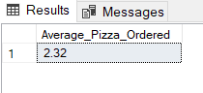

Daily Trend for Total Orders:
SELECT DATENAME(DW,order_date) AS Order_Day,
COUNT(DISTINCT(order_id)) AS Total_Orders FROM pizza_sales
GROUP BY DATENAME(DW,order_date)
ORDER BY Total_orders desc; Output:
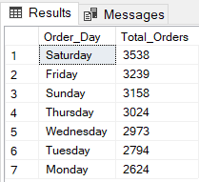

Monthly Trend for Total Orders:
SELECT DATENAME(MONTH,order_date) AS Order_Month,
COUNT(DISTINCT(order_id)) AS Total_Orders FROM pizza_sales
GROUP BY DATENAME(MONTH,order_date) ORDER BY Total_orders desc;
Output:
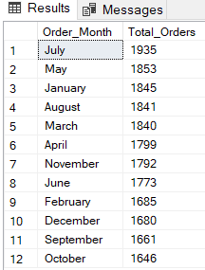

Hourly Trend for Total Orders:
SELECT DATENAME(HOUR,order_time) AS Order_Time,
COUNT(DISTINCT(order_id)) AS Total_Orders FROM pizza_sales
GROUP BY DATENAME(HOUR,order_time) ORDER BY Total_orders desc;
Output:
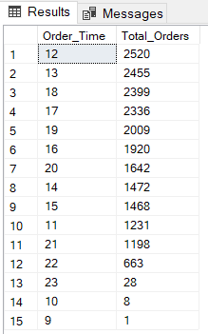
Percentage of Sales by Pizza Category:

SELECT pizza_category,
SUM(total_price) AS Total_sales,
CAST(SUM(total_price)*100/
(SELECT SUM (total_price)FROM pizza_sales)AS decimal(10,2)) AS Sales_Percentage
FROM pizza_sales
GROUP BY pizza_category
ORDER BY Sales_Percentage desc;

Output:
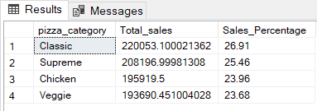

NOTE-: If you want to filter out the date with respect to month, Use “WHERE” clause. Example as below:-

SELECT pizza_category,
CAST (SUM(total_price)AS decimal(10,2)) AS Total_sales,
CAST(SUM(total_price)*100/
(SELECT SUM (total_price)FROM pizza_sales WHERE MONTH(order_date)=2 )AS decimal(10,2)) AS Sales_Percentage
FROM pizza_sales
WHERE MONTH(order_date)=2
GROUP BY pizza_category;

Output:
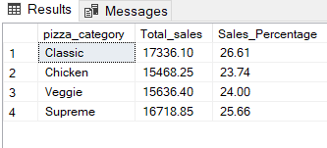

** Here MONTH(order_date)=2 Idicates that the ouput is for the second the month which is February.
In the similar manner if we want the results w.r.t. quarter we will use “WHERE DATEPART (QUARTER,order_date)=2”

Percentage of Sales by Pizza Size:
SELECT pizza_size,
CAST(SUM(total_price)AS decimal(10,2)) AS Total_sales,
CAST(SUM(total_price)*100/
(SELECT SUM (total_price)FROM pizza_sales) AS decimal(10,2))AS Sales_Percentage
FROM pizza_sales
GROUP BY pizza_size
ORDER BY Sales_Percentage desc;
Output:
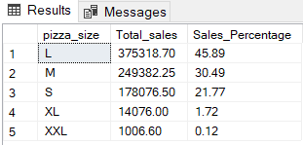

Total Pizzas Sold by Pizza Category:
SELECT pizza_category, SUM(quantity) AS Total_Pizza_sold FROM pizza_sales
GROUP BY pizza_category;
Output:
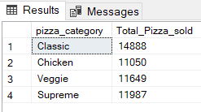

Top 5 Best Sellers by Revenue, Total Quantity and Total Orders
Top 5 by Revenue/Sales
SELECT TOP 5 pizza_name AS Pizza_Name,
CAST(SUM(total_price) AS decimal(10,2))AS Total_Sales FROM pizza_sales
GROUP BY pizza_name
ORDER BY Total_Sales DESC;

Output:
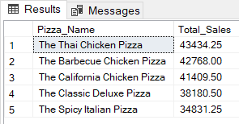

Top 5 by Quantity
SELECT TOP 5 pizza_name AS Pizza_Name,
SUM(quantity) AS Total_Quantity FROM pizza_sales
GROUP BY pizza_name
ORDER BY Total_Quantity DESC;
Output:
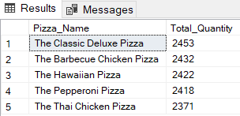

Top 5 by total orders
SELECT TOP 5 pizza_name AS Pizza_Name, COUNT(DISTINCT order_id) AS Total_order FROM pizza_sales
GROUP BY pizza_name
ORDER BY Total_order DESC;
Output:
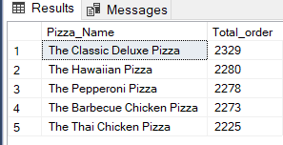

Bottom 5 Best Sellers by Revenue, Total Quantity and Total Orders
Wrost 5 by Revenue/Sales
SELECT TOP 5 pizza_name AS Pizza_Name,
CAST(SUM(total_price) AS decimal(10,2))AS Total_Sales FROM pizza_sales
GROUP BY pizza_name
ORDER BY Total_Sales ASC;
Output:
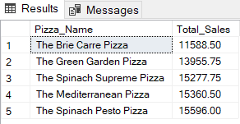
Wrost 5 by total quantity
SELECT TOP 5 pizza_name AS Pizza_Name,
SUM(quantity) AS Total_Quantity FROM pizza_sales
GROUP BY pizza_name
ORDER BY Total_Quantity ASC;
Output:
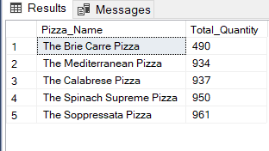
Wrost 5 by total orders
SELECT TOP 5 pizza_name AS Pizza_Name,
COUNT(DISTINCT order_id) AS Total_order FROM pizza_sales
GROUP BY pizza_name
ORDER BY Total_order ASC;
Output:
